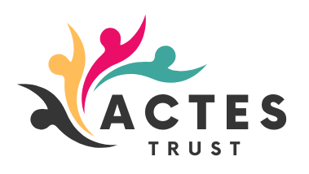

01/05/2025
Dear Applicant

Post of: Middlesbrough Youth Mutual Careers IAG Officer

Thank you for your interest in the above post with Actes Trust. Please find enclosed an application form, equal opportunities monitoring form, job description, person specification and information pack.

If you are applying for this post, please:
- Complete the application in full
- Complete the enclosed monitoring form

A CV may be submitted alongside a fully completed application as a supporting document however, this is not a mandatory requirement.
Completed applications should be emailed to: johnny.harrison@actes.co.uk

Or alternatively, posted or hand delivered to:
Recruitment Section
Actes Trust
99 Acklam Road
Middlesbrough
TS5 5HR

Please note the closing date for this application is: Midnight Tuesday 3rd June 2025

I do hope you take your interest in the post to a formal application. In the meantime, if you have any queries or wish to have an informal discussion about the post, please contact Paul Wales on 07850 916 308 or via email: paul.wales@actes.co.uk

Yours Sincerely

Johnny Harrison
Programme and Development Team Leader

